Intrusion Detection System Using Data Mining Techniques

Project ID: 21232
B.Tech. Project Report
submitted for fulfillment of
the requirements for the
Degree of Bachelor of Technology
Under Biju Pattnaik University of Technology

Submitted By
Sunil Maharana ROLL NO. CSE-201742265
Kashis Jena ROLL NO. CSE-201741214


2020 – 2021

Under the guidance of
Ms. Manisha Patro

NATIONAL INSTITUTE OF SCIENCE & TECHNOLOGY
Palur Hills, Berhampur, Odisha – 761008, India

TABLE OF CONTENTS

TABLE OF CONTENTS 2
LIST OF FIGURES 3
ABSTRACT 4
1. INTRODUCTION 5
1.1 Definition 5
2. DATASET 6
3. ALGORITHMS USED 7
3.1 K-Nearest Neighbour 7
3.2 Naïve Bayes 9
3.3 Decision Trees 10
3.4 Logistic Regression 12
3.5 Support Vector Machine 14
4. PERFORMANCE METRICS 16
Confusion Matrix 16
5. RESULTS 18
Confusion Matrix 18
Accuracy 20
Bar Graph 22
6. CONCLUSION 23
REFERENCE 24

LIST OF FIGURES

Figure 1.1 Intrusion Detection System 5
Figure 2.1 NSL-KDD Dataset 6
Figure 3.1 K-Nearest Neighbour 7
Figure 3.2 Naïve Bayes Formula 9
Figure 3.3 Decision Tree Flow Diagram 11
Figure 3.4 Logistic Regression 13
Figure 3.5 Support Vector Machine 14
Figure 4.1 Confusion Matrix 16
Figure 5.1 Classifier Accuracy Comparison 22

ABSTRACT
As the network-based applications are growing rapidly, the network security mechanisms require more attention to improve speed and precision. The ever-evolving new intrusion types pose a serious threat to network security. Although numerous network security tools have been developed, yet the fast growth of intrusive activities is still a serious issue. Intrusion detection systems (IDSs) are used to detect intrusive activities on the network. Machine learning and classification algorithms help to design "Intrusion Detection Models" which can classify the network traffic into intrusive or normal traffic. In this paper we present the comparative performance of NSL-KDD based data set compatible classification algorithms. These classifiers have been evaluated using 41 attributes. Around 94,000 instances from complete KDD dataset have been included in the training data set and over 48,000 instances have been included in the testing data set. Random Forest, Decision Tree and Naïve Bayes are the three classification algorithms that are used in this comparative study. Keywords--Machine Learning; Classification Techniques; NSL-KDD Dataset; Data Mining; Random Forest; Decision Tree ; Naïve Bayes.

1. INTRODUCTION
Intrusion detection is a type of security management system for computers and networks. An ID system gathers and analyses information from various areas within a computer or a network to identify possible security breaches, which include both intrusions i.e., the attacks from outside the organization and misuse attacks from within the organization. KDD process is used to denote the process of extracting useful knowledge from large dataset. Data Mining is the process of discovering knowledge from the large amount of dataset. Data Mining is the most vital step in the NSL-KDD process and it applies it to extract patterns from the data. The recent development in data mining has made available a wide variety of algorithms, drawn from the fields of statics, pattern recognition, machine learning and database. We have more chances of data loss; hacking and intrusion have been increased with the growth and popularity of the Internet. When continuously growing, Internet attacks suppose severe challenges to develop a flexible and adaptive security oriented methods.
An intrusion can be defined as a series of actions that compromises the integrity, confidentiality or availability of a computer resource. Intrusion Detection System (IDS) is one of the most important components being used to detect the Internet attacks that can be either host based or network based.

1.1 DEFINITION
Intrusion detection is the process of monitoring and analyzing the activities occurring in a computer system or in a network in order to detect signs of security problems. IDS need only to detect threats and as such is placed out-of-band on the network infrastructure, meaning that it is not in the true real-time communication path between the sender and receiver of information. In some cases, the IDS may also respond to anomalous or malicious traffic by taking action such as blocking the user from accessing the network.
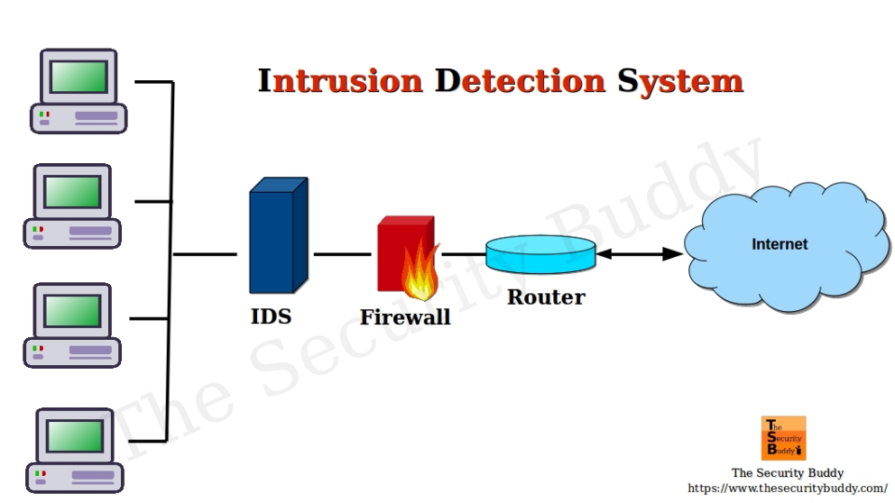

Figure 1.1 Intrusion Detection System

2. DATASET
NSL-KDD is a dataset for network-based intrusion detection systems. It contains essential records of the complete KDD99 Cup data set. It is the new version of KDD Cup99 dataset.

The testing dataset used for experimental purposes has 22 different attacks out of total 37 present in the dataset. The training dataset used for experimental purposes has 23 different attacks out of total 37 present in the dataset. NSL KDD data set is made up of 41 different attributes and there are five attack classes one of which is normal and other four are different types of attack. The features are given in the diagram below:

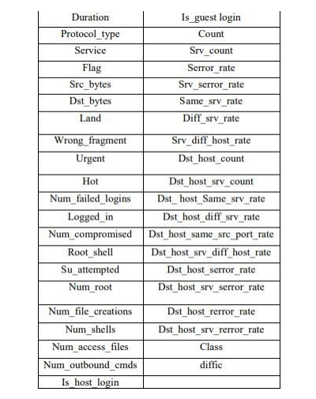
Figure 2.1 NSL-KDD Dataset

3. ALGORITHMS USED
A brief overview of three popular algorithms that have been applied to the study of intrusion detection is given below.

3.1 K-Nearest Neighbour(KNN)
K-Nearest Neighbour is one of the simplest Machine Learning algorithms based on Supervised Learning technique.
K-NN algorithm assumes the similarity between the new case/data and available cases and put the new case into the category that is most similar to the available categories. This algorithm stores all the available data and classifies a new data point based on the similarity. This means when new data appears then it can be easily classified into a well suite category by using K- NN algorithm. This algorithm can be used for Regression as well as for Classification but mostly it is used for the Classification problems.
It is also called a lazy learner algorithm because it does not learn from the training set immediately instead it stores the dataset and at the time of classification, it performs an action on the dataset. KNN algorithm at the training phase just stores the dataset and when it gets new data, then it classifies that data into a category that is much similar to the new data.
K-nearest neighbors (KNN) algorithm is a type of supervised ML algorithm which can be used for both classification as well as regression predictive problems. However, it is mainly used for classification predictive problems in industry.

The following two properties would define KNN well −
- Lazy learning algorithm − KNN is a lazy learning algorithm because it does not have a specialized training phase and uses all the data for training while classification.
- Non-parametric learning algorithm − KNN is also a non-parametric learning algorithm because it doesn’t assume anything about the underlying data.

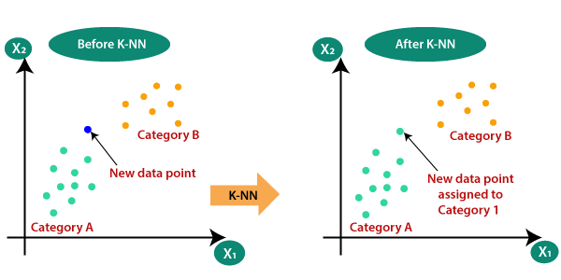
Figure 3.1 K-Nearest Neighbour

3.2 Naïve Bayes
A Bayesian network is a model that encodes probabilistic relationships among variables of interest. Naive Bayesian classifiers use the Bayes theorem to classify the new instances of data. Each instance is a set of attribute values described by a vector, 𝑋 = (𝑥1, 𝑥2 . . . , 𝑥𝑛).
Considering m classes, the sample X is assigned to the class Ci if and only if 𝑃(𝑋|𝐶𝑖)𝑃(𝐶𝑖) > 𝑃(𝑋|𝐶𝑗 )𝑃(𝐶𝑗 ) for all j in (1, m) such that j = 6 I.
Naïve Bayesian technique is generally used for intrusion detection in combination with statistical schemes, a procedure that yields several advantages, including the capability of encoding interdependencies between variables and of predicting events, as well as the ability to incorporate both prior knowledge and data. Naïve Bayesian classifiers simplify the computations and exhibit high accuracy and speed when applied to large databases. A disadvantage of using Bayesian networks is that their results are similar to those derived from threshold-based systems, while considerably higher computational effort is required. Lack of available probability data is a significant disadvantage of the naïve Bayesian approach to IDS. Another disadvantage is that in Naïve Bayes approach it is assumed that the data attributes are conditionally independent which is not always so (it should be noted however that despite this, Bayesian classifiers give satisfactory results because focus is on identifying the classes for the instances, not the exact probabilities)
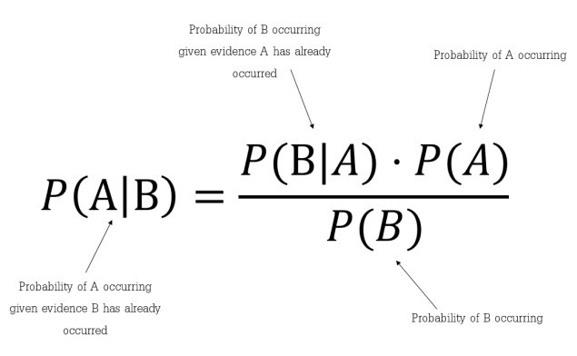
Figure 3.2 Naïve Bayes Formula

3.3 Decision Trees
Decision tree is a predictive modeling technique most often used for classification in data mining. The Classification algorithm is inductively learned to construct a model from the pre-classified data set. Each data item is defined by values of the attributes and classification may be viewed as mapping from a set of attributes to a particular class. Each non-terminal node in the decision tree represents a test or decision on the considered data item. Choice of a certain branch depends upon the outcome of the test.
To classify a particular data item, we start at the root node and follow the assertions down until we reach a terminal node (or leaf). A decision is made when a terminal node is approached. An advantage of using decision tree algorithms for IDS is that its construction does not require any domain knowledge. Hence a data mining expert with little knowledge of networking can help build accurate decision tree models. Another significant advantage is that decision trees can handle high dimensional data. This increases the suitability of decision tree algorithms for IDS especially while considering the heterogeneity of network connection data and its ever-increasing size.
Decision trees are able to process both numerical and categorical data (this suits the alphanumeric nature of network connection data). Finally, decision tree representations are easy to understand hereby making it easier for the network analyst to identify network trends and deviations from normal traffic. Disadvantages of decision tree algorithms in IDS are that the output attribute must be categorical (normal or anomaly) and limited to one output attribute. Decision tree algorithms are also known to be unstable and trees created from numeric datasets can be complex.

Decision tree analysis is a predictive modelling tool that can be applied across many areas. Decision trees can be constructed by an algorithmic approach that can split the dataset in different ways based on different conditions. Decisions tress are the most powerful algorithms that falls under the category of supervised algorithms.

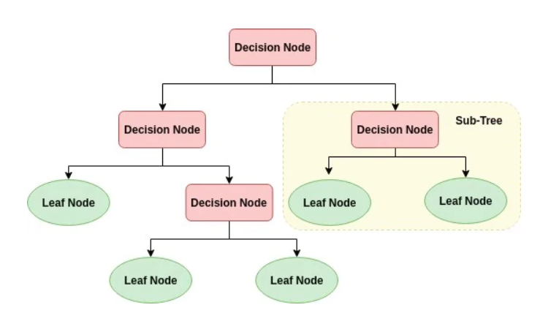
Figure 3.3 Decision Tree Flow Diagram

In the above decision tree, the question are decision nodes and final outcomes are leaves. We have the following two types of decision trees –
- Classification decision trees − In this kind of decision trees, the decision variable is categorical. The above decision tree is an example of classification decision tree.
- Regression decision trees − In this kind of decision trees, the decision variable is continuous.

3.4 Logistic Regression
Logistic Regression is a statistical model that in its basic form uses a logistic function to model a binary dependent variable, although many more complex extensions exist. In regression analysis, logistic regression (or logit regression) is estimating the parameters of a logistic model (a form of binary regression).

Mathematically, a binary logistic model has a dependent variable with two possible values, such as pass/fail which is represented by an indicator variable, where the two values are labeled "0" and "1". In the logistic model, the log-odds (the logarithm of the odds) for the value labeled "1" is a linear combination of one or more independent variable ("predictors"); the independent variables can each be a binary variable (two classes, coded by an indicator variable) or a continuous variable (any real value). The corresponding probability of the value labeled "1" can vary between 0 (certainly the value "0") and 1 (certainly the value "1"),
Hence the labeling; the function that converts log-odds to probability is the logistic function, hence the name. The unit of measurement for the log-odds scale is called a logit, from logistic unit, hence the alternative names.
Analogous models with a different sigmoid function instead of the logistic function can also be used, such as the probit model; the defining characteristic of the logistic model is that increasing one of the independent variables multiplicatively scales the odds of the given outcome at a constant rate, with each independent variable having its own parameter; for a binary dependent variable this generalizes the odds ratio.
Logistic regression is a supervised learning classification algorithm used to predict the probability of a target variable.
The nature of target or dependent variable is dichotomous, which means there would be only two possible classes.

In simple words, the dependent variable is binary in nature having data coded as either 1 (stands for success/yes) or 0 (stands for failure/no).
Mathematically, a logistic regression model predicts P(Y=1) as a function of X. It is one of the simplest ML algorithms that can be used for various classification problems such as spam detection, Diabetes prediction, cancer detection etc.

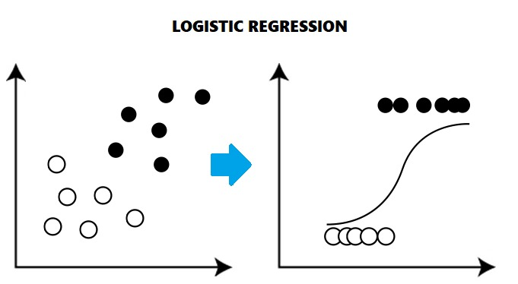
Figure 3.4 Logistic Regression

3.5 Support Vector Machine (SVM)
A support vector machine (SVM) is a supervised machine learning model that uses classification algorithms for two-group classification problems. After giving an SVM model sets of labeled training data for each category, they’re able to categorize new text.
SVMs are one of the most robust prediction methods, being based on statistical learning frameworks or VC theory proposed by Vapnik and Chervonenkis (1974) and Vapnik (1982, 1995).
An SVM training algorithm builds a model that assigns new examples to one category or the other, making it a non-probabilistic binary linear classifier (although methods such as Platt scaling exist to use SVM in a probabilistic classification setting).

SVM maps training examples to points in space so as to maximise the width of the gap between the two categories. New examples are then mapped into that same space and predicted to belong to a category based on which side of the gap they fall.

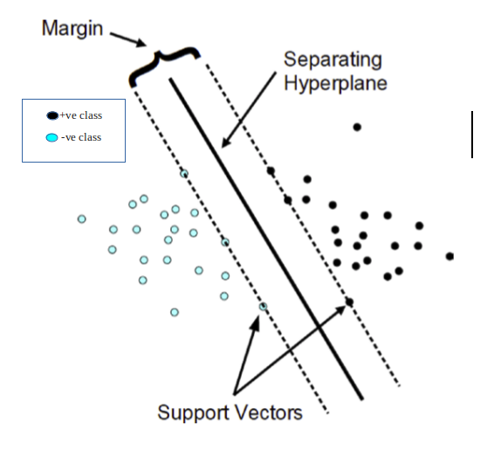
Figure 3.5 Support Vector Machine

The followings are important concepts in SVM −
Support Vectors − Datapoints that are closest to the hyperplane is called support vectors. Separating line will be defined with the help of these data points.
Hyperplane − As we can see in the above diagram, it is a decision plane or space which is divided between a set of objects having different classes.
Margin − It may be defined as the gap between two lines on the closet data points of different classes. It can be calculated as the perpendicular distance from the line to the support vectors. Large margin is considered as a good margin and small margin is considered as a bad margin.

4. PERFORMANCE METRICS
The performance metrics used to evaluate classification:

Confusion Matrix:

It contains information about actual and predicted classifications done by a classification system.
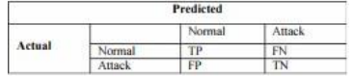
Figure 4.1 Confusion Matrix

- False positive (FP): It defines the number of detected attacks which are actually normal.
- False negative (FN): It means wrong prediction i.e. it means it detects instances a normal but in actual they are attacks.
- True positive (TP): It means instances that are correctly predicted as normal.
- True negative (TN): It means instances that are correctly classified or detected as attack.
- Accuracy: It is the percentage of correct predictions. On the basis of Confusion Matrix, it is calculated by using the formula below:
Accuracy= TP+TN/n
n is total number of instances.
- Mean Absolute Error: It is the mean of overall error made by classification algorithm. Least the error and best will be the classifier.

- TPR: True Positive Rate is same as accuracy so we have not considered this metrics. FPR: False Positive Rate is calculated by using the formula:
FPR=FPITN+FP
- Recall: It is the proportion of instances belonging to the positive class that are correctly predicted as positive.
Recall=TPITP+ FN
- Precision: It is a measure which estimates the probability that a positive prediction is correct.
Precision = TPITP+FP
- Training time: It is the time taken by Classifier to build the model on dataset. It is usually measured in seconds.
- Kappa: Its value ranges from 0 to 1. 0 means totally disagreement and I means full agreement. It checks the reliability of Classifying algorithm on dataset.
- ROC (Receiver Operating Characteristics): It is used to design tdhe curve between TPR and FPR and the area under curve is called as AUC gives the value of ROC. More the area under curve and more will be the value of ROC.

5. RESULTS

Confusion Matrix:

• Naïve Bayes
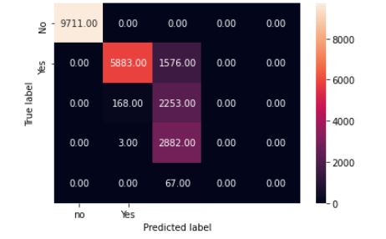

• Decision Tree
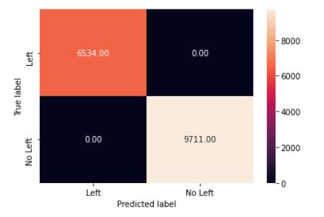

• K-Nearest Neighbour
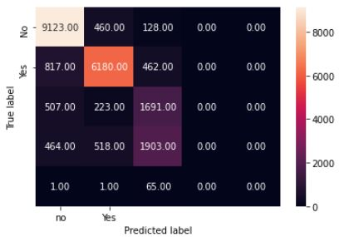

• Logistic regression
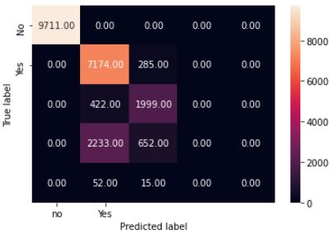

• Support Vector machine
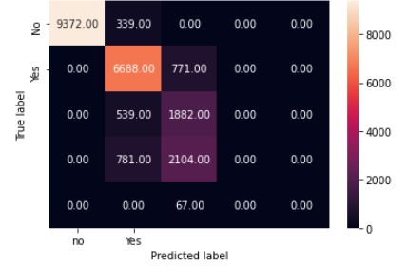

Accuracy:

• Naïve Bayes
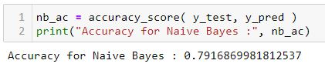

• Decision Tree
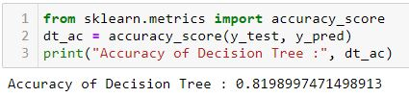

After Fine Tuning the Parameters:

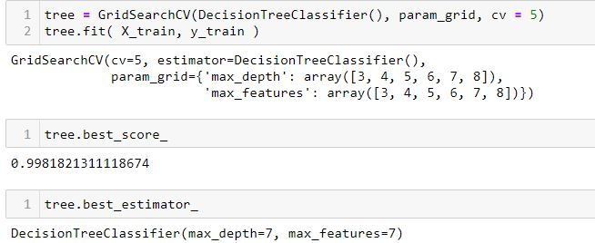

• K-Nearest Neighbour
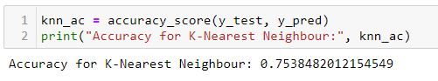

• Logistic Regression
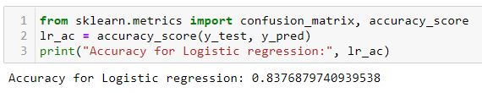

• Support Vector Machine
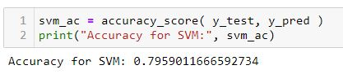

Bar Graph:
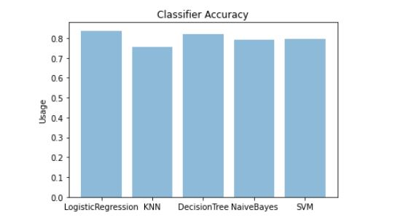
Figure 5.1 Classifier Accuracy Comparison

7. CONCLUSION
The comparative study concludes that, the Logistic Regression classifier performed the best on NSLKDD dataset, providing an accuracy of 83.76, and The accuracy of the Naïve Bayes classifier is 75.38 which is considerably less in comparison to the KNN Classifier.

REFERENCE
- Aleksandar Lazarevic, LeventErtoz, Vipin Kumar, AyselOzgur, Jaideep Srivastava, “A Comparative Study of Anomaly Detection Schemes in Network Intrusion Detection”

- Y. Kim, W. N. Street, F. Menczer, and G. J. Russell, “Feature selection in data mining” in Data Mining: Opportunities and Challenges: J. Wang, Ed. Hershey

- Saurabh Mukherjeea, Neelam Sharmaa, Intrusion Detection using Naive Bayes Classifier with Feature Reduction,Procedia Technology 4, 2012, pp.119-128.

- M. Tavallaee, E. Bagheri, W. Lu, and A. Ghorbani, “A Detailed Analysis of the KDD CUP 99 Data Set,” Submitted to Second IEEE Symposium on Computational Intelligence for Security and Defense Applications (CISDA), 2009.

